2200031128 CH BHAVANA
HandsOn Task 3 :
Create a react app for Student Management Portal named scorecalculatorapp and create a function component named “CalculateScore” which will accept Name, School, Total and goal in order to calculate the average score of a student and display the same.
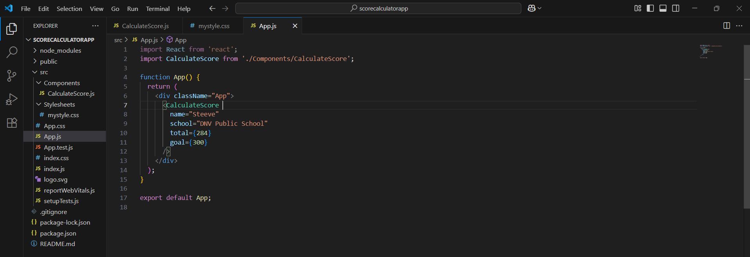
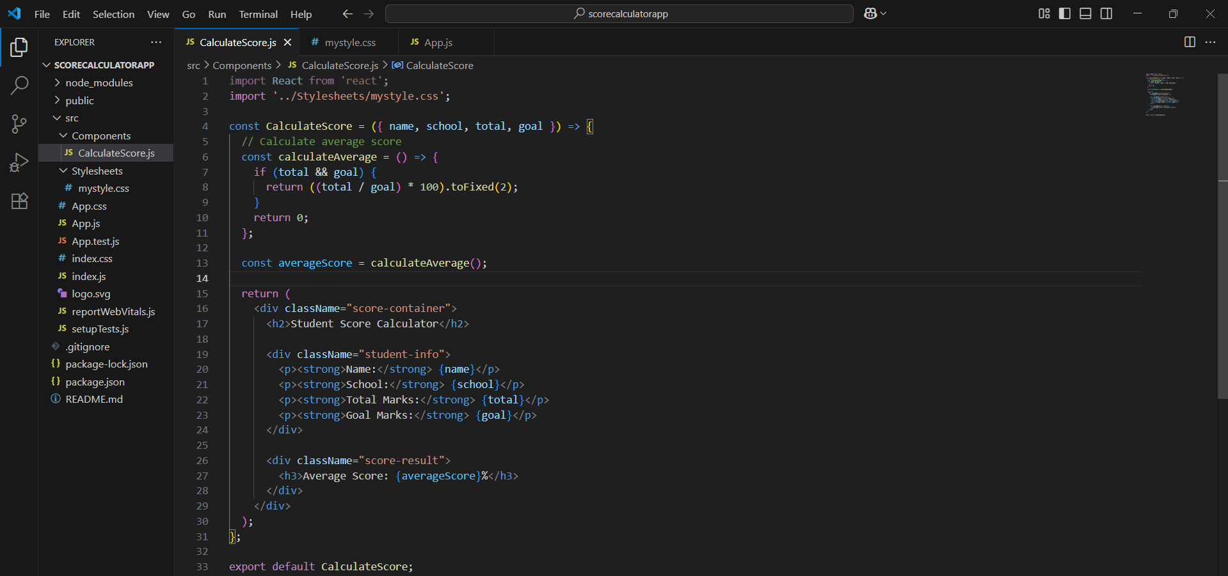
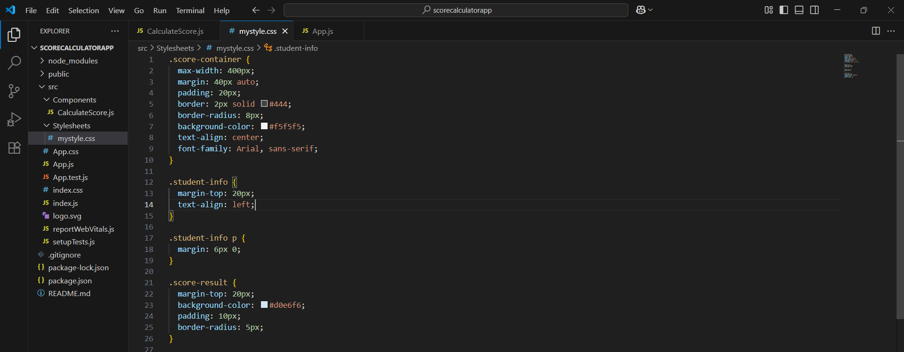
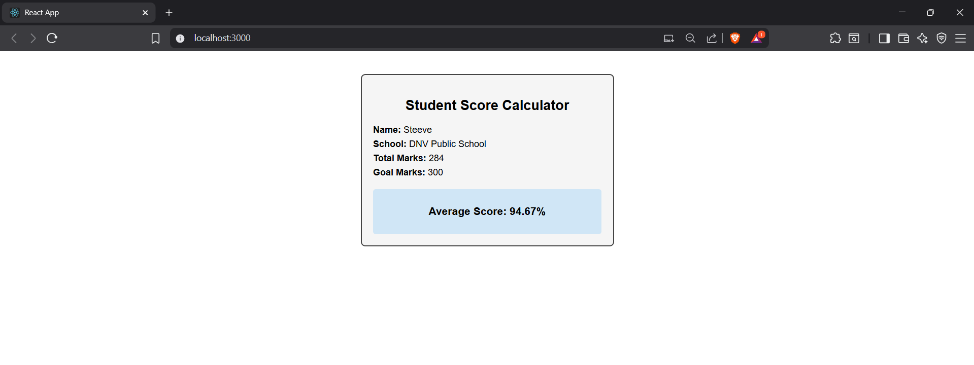
🧱 Step 1: Create React App
npx create-react-app scorecalculatorapp
📂 Step 2: Go into Project Folder and Run
cd scorecalculatorapp
🗂️ Step 3: Create Components Folder
- Why: To keep custom components in one place
- What: Inside src, create a folder named Components
🧩 Step 4: Create CalculateScore.js Component
- Why: To show student info and calculate average score
- What it does:
  - Takes values like name, school, total, goal using props
  - Calculates average = (total / goal) * 100
  - Displays everything using JSX
🎨 Step 5: Create Stylesheets/mystyle.css
- Why: To make the UI look better
- What:
  - Inside src, create folder Stylesheets
  - Add CSS file mystyle.css
  - Import this file inside CalculateScore.js
🧠 Step 6: Use the Component in App.js
- Why: To actually display it in the browser
- What:
  - Import CalculateScore
  - Pass values using props inside <CalculateScore />
🚀 Step 7: Run the App
To see the final result with calculation

